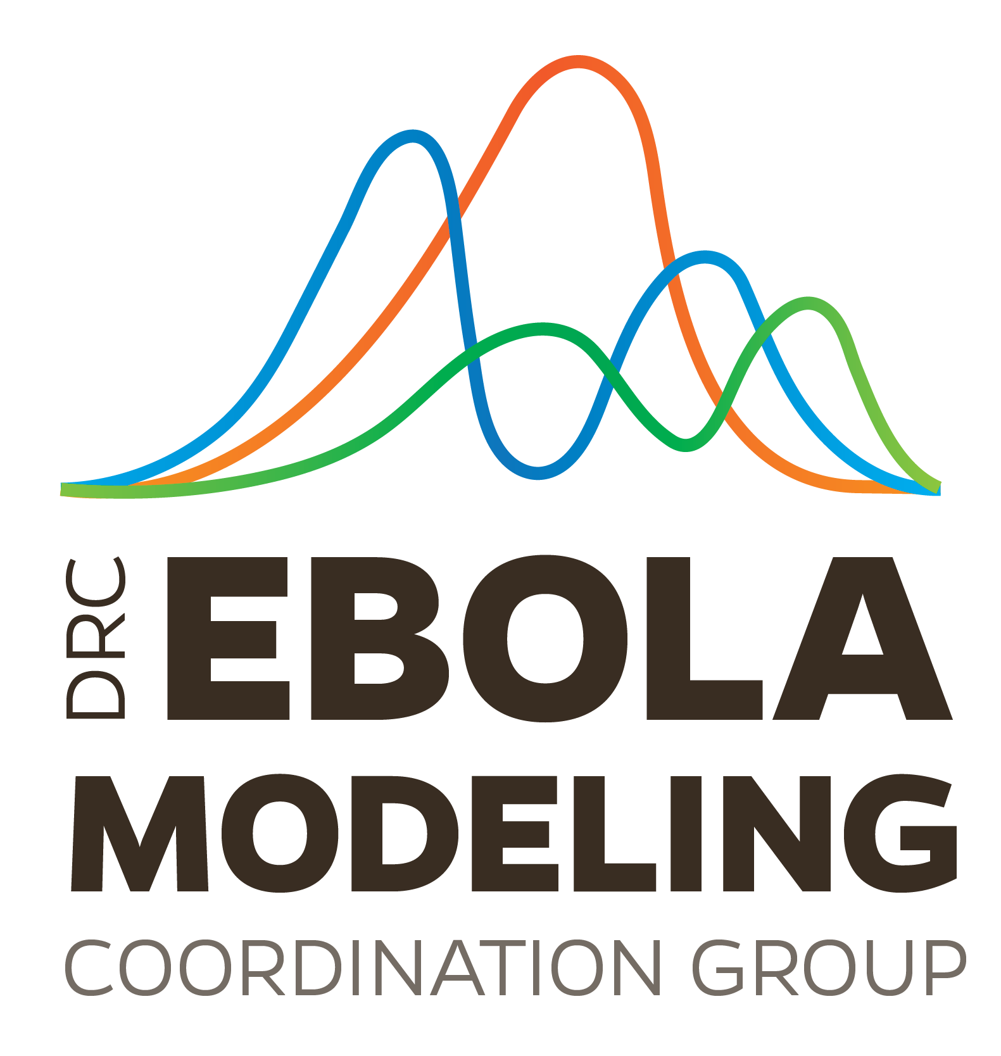**September 2019 Ebola Modeling Coordination Group Meeting Notes**

Approximately 40 participants joined from a range of sectors, including academia in the US and the UK, the US Federal Government, and NGOs.

Rae Wannier (UCSF) presented on the role of conflict in driving transmission in the 2018-2019 Ebola virus outbreak. The model used ACLED and WHO data to generate time-varying status of exposure to recent conflict for each health zone and by the type of conflict (e.g., interruptions in contact tracing, reduction in care seeking behavior). For additional details, contact Rae at rae.wannier@ucsf.edu.

Dr. Trevor Bedford (Fred Hutchinson) presented on the Nextstrain tool, particularly the North Kivu Ebola outbreak. Dr. Bedford discussed how Ebola samples are being sequenced at labs in Kinshasa by INRB, and the resulting phylogenetic analyses are being deployed live on the Nextstrain website. These phylogenetic analyses could have operational applications, such as improving contact tracing. For additional details, contact Dr. Bedford at trevor@bedford.io, or visit <https://nextstrain.org.>

Dr. Cecile Viboud further explored the idea of creating a modeling challenge around the DRC Ebola outbreak. To weigh in, contact Dr. Viboud at viboudc@mail.nih.gov.

Following the presentations, participants discussed how the phylogenetic data is being fed back to coordination and surveillance teams, and whether sequencing of samples could be completed on the front lines of the outbreak. Particularly, participants noted the inherent logistical challenges of having this capacity at the location of the outbreak. Participants also discussed the value in identifying whether conflict can predict vaccination uptake in a given location.

To continue coordination, please join our slack channel (ebolamcg.slack.com) at:

https://join.slack.com/t/ebolamcg/shared_invite/enQtNzIwMDM1OTIwMDgxLTg4ZDEwMDA0MDAxODE2NTdmZmQxMmM5MDMyNmY3YzI2NDUwNDhhM2M1YWYyMjU3MDY3ZDE1ZjkzZGFmMzg5NDg